Homemade Bagels Recipe
STELLA PARKS
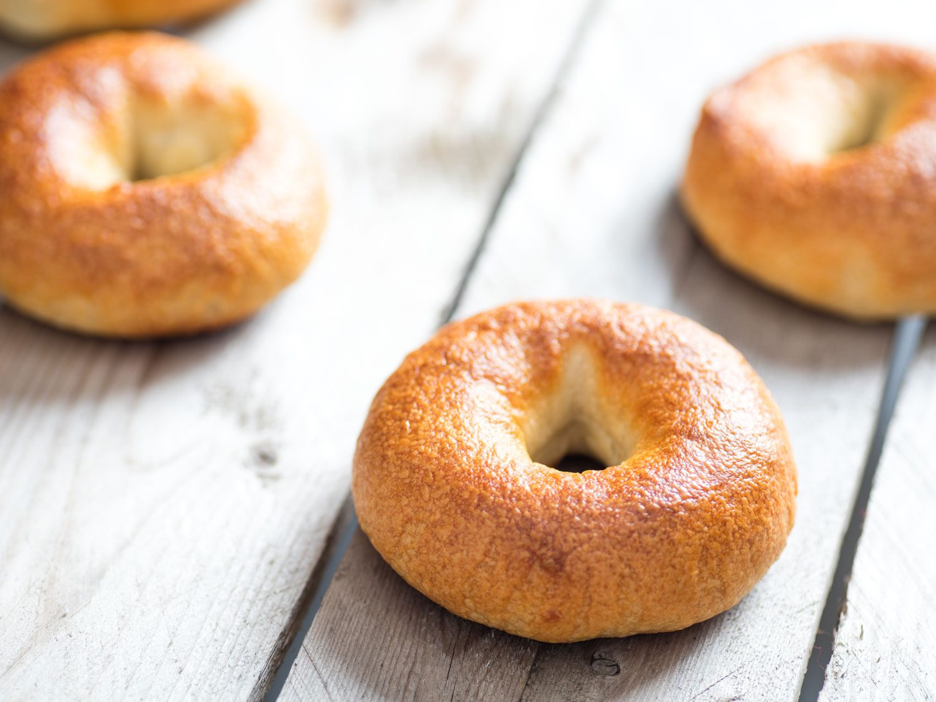

[Photograph: Vicky Wasik]
My method isn't exactly traditional, but it's a surefire way to guarantee homemade bagels that stay fresh long enough to enjoy them a few days in a row. They're chewy but tender, with a blistered crust that's eggshell thin and perfectly crisp. The trick is to pre-cook a portion of the flour and water on the stovetop, which improves browning and moisture retention and leads to bagels that won't turn into bricks overnight.

Why It Works
- Pregelatinizing a portion of flour improves browning and shelf life, while creating a tighter crumb.
- Pre-shaped boules are easily stretched into seamless rings, a technique that's gentler on the underlying gluten structure, too.
- Boiling halts the dough's rise, creating crumb tight, while malt syrup in the water improves the flavor and aroma of the crust.
Read more: Magic Bagels: They Stay Fresh for Days

- YIELD:makes 8 three-inch bagels
- ACTIVE TIME:30 minutes
- TOTAL TIME:25 hours
- RATED:

Ingredients
- For the Yukone:
- 6 ounces cold water (3/4 cup; 170g)
- 3 1/2 ounces bread flour (about 3/4 cup, spooned; 100g)
- For the Dough:
- 12 1/2 ounces bread flour (about 2 3/4 cups, spooned; 355g)
- 1/2 ounce sugar (1 tablespoon; 15g)
- 2 1/2 teaspoons (9g) Diamond Crystal kosher salt; for table salt, use half as much by volume or use the same weight
- 1 teaspoon instant dry yeast (4g)(see note)
- 3 1/2 ounces water (1/2 cup minus 1 tablespoon; 100g)
- To Boil:
- 1 ounce barley malt syrup (4 teaspoons; 30g), optional
- Directions1.
For the Yukone: In a 10-inch skillet, whisk water and flour over medium heat until the paste is a thick lump, about 2 minutes. Scrape onto a plate, spread into a 1-inch layer, cover and cool until to about 75°F (23°C), around 30 minutes.
- 2.
For the Dough: Pulse flour, sugar, salt, and instant yeast in a food processor fitted with a metal blade. Once combined, add cooled yukone and water (if using active dry yeast, first dissolve with the water). Process until dough is silky smooth, about 90 seconds. Turn dough onto a clean, un-floured surface, and divide into 8 roughly equal portions (3 ounces or 85g each).
- 3.
To Shape: Cup a portion of dough beneath your palm and work in quick, circular motions to form a tight skin around the ball, with only a tiny seam along the bottom. If the seam is large or irregular, continue rounding until the bottom is nearly smooth. Cover with plastic and let rest 15 minutes. Poke a hole into the center of each portion with a damp fingertip, then gently stretch into a 3 1/4-inch ring, wetting your hands in cold water as needed to prevent sticking. Arrange on a well greased, parchment-lined half sheet pan, cover with plastic, and refrigerate 24 to 36 hours, depending on your schedule.
- 4.
To Boil: Adjust oven rack to lower-middle position and preheat to 425°F (218°C). Fill a stainless steel pot with about 3 inches of water, stir in malt (if using), and bring to a boil over high heat. Meanwhile, line a baking sheet or cutting board with a thick layer of paper towels. Working two or three at a time, boil the bagels about 30 seconds per side. Place on paper towels, then immediately transfer to a parchment-lined half sheet pan (if left on the paper towels too long, the bagels will stick; if this happens, quickly dip the bagel back into the hot water, and the wet paper towel will peel right off).
- 5.
To Finish: Bake until blistered and golden brown all over, about 25 minutes. Cool at least 15 minutes. To serve, split horizontally with a serrated knife. Uncut, bagels can be stored up to 48 hours in a paper bag (or loosely wrapped in parchment), then sliced and briefly toasted to serve.

Special Equipment
10-inch skillet, food processor, 3- or 4-quart stainless steel pot

Notes
Bagels that are both chewy and flavorful do best with bread flour made from hard red wheat; for this recipe, my favorite is King Arthur. Other brands may include a portion of hard white wheat, a mellow variety that can leave bagels tasting flat. You can use active dry yeast in place of instant. If using active dry, in Step 2, dissolve the yeast in the water before incorporating with the rest of the dough ingredients in the food processor.

